**A2-1: Basic Command Line**

* Get help with the IPConfig utility

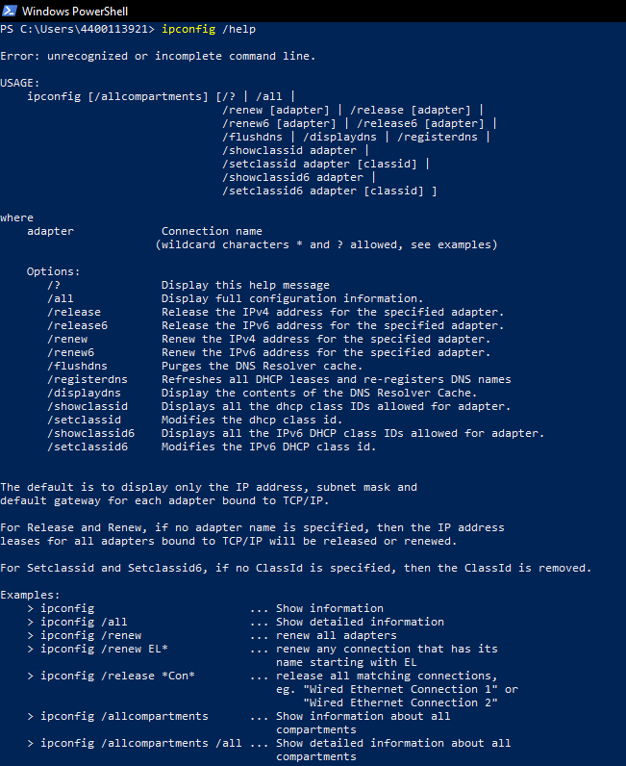

* Go to your user's Document folder

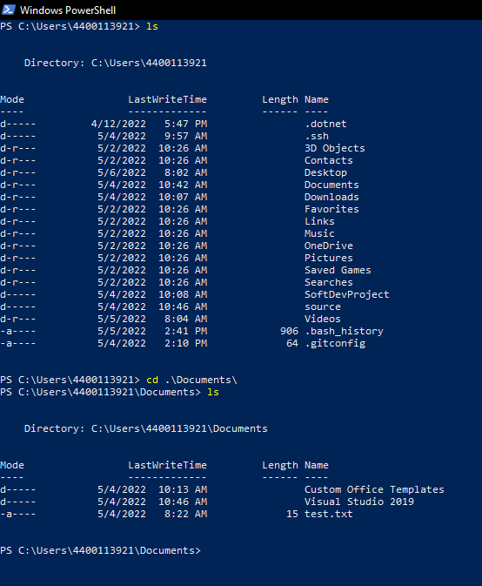

* Copy a file to another location

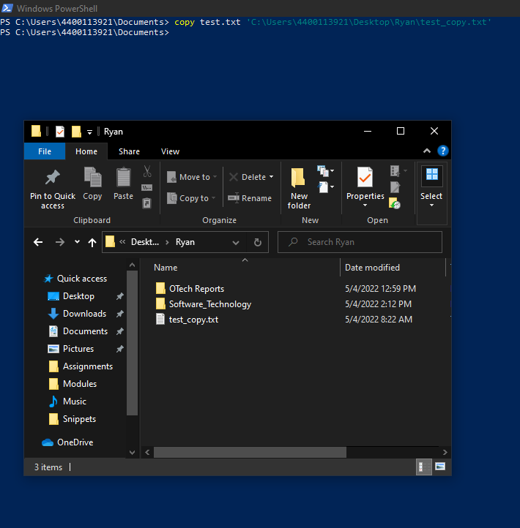

* Move a file to another location

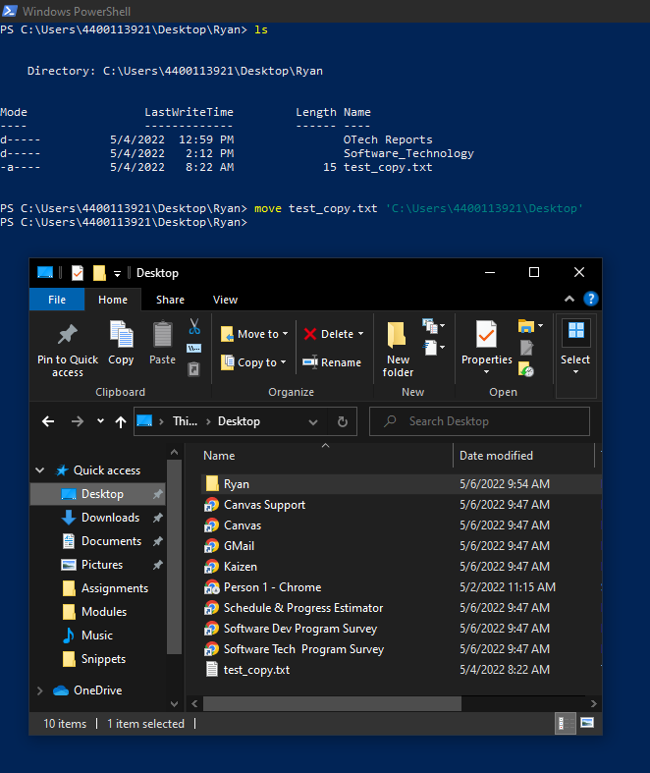

* Make a directory in your user's folder (For example C:\Users\MyName\ everyone will have a different user directory inside Users)

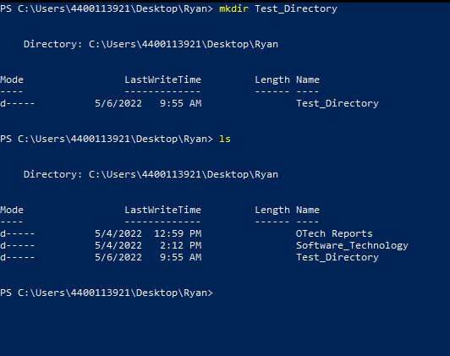

* Install Git and add it to the PATH variable

